# **ER-Diagram and Schema Diagram**

**ER-Diagram:**

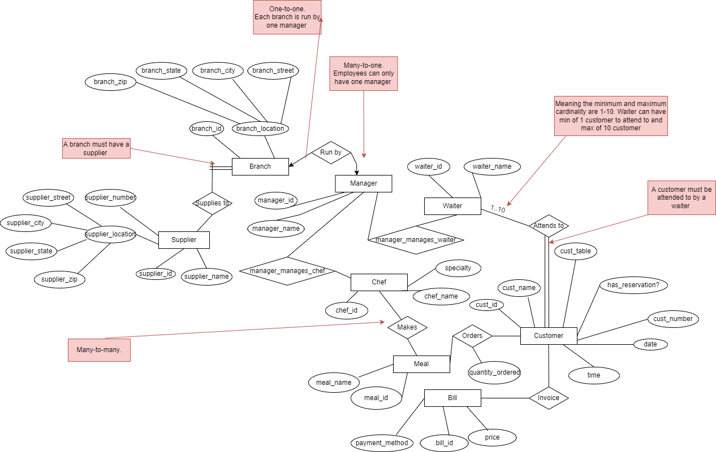

**Schema Diagram:**

